

Address Book Update Tool 1.0
Using Active Directory

Functional Spec



Messaging IT
Microsoft Corporation

Managed Document
Doc Name
Version | 1.0
Analyst | Vikramaditya Reddy J
Filename | Functional_Specs_ABUpdateTool.doc
Approval Status: | DRAFT

- Introduction
This Document is intended to list out the Functional specification for the Address Book Update tool.

- Version History
Analyst | Date | Ver | Description
t-vreddy | 04/12/05 | 1.0 | Under Development
t-vreddy | 05/02/05 | 1.0 a | Under Development

- About this Document
This document contains the functional requirements for Address Book Update Tool.

This document will serve as a technical Functional Spec and will be used by the QA Test team to write test cases. Although this document contains some technical information, the detailed design will serve as the final authority for data, interface jobs, etc.

- Related Documents

- Test cases to be generated (Test Cases will be Documented).

- Contacts

Contact | Role
Jon Edwards | SENIOR OPERATIONS MANAGER-ECS
Krishna R | OPERATIONS MANAGER
Lyle Rice | SENIOR OPERATIONS ANALYST
Vikramaditya Reddy J | INTERN

- Management Summary
The main feature for the Address Book Update Tool is to accept the user general fields which are:

On the Phone/Notes tab:
Notes Field

On the General tab:
Address Field
City Field
State Field
Zip Code Field
Country/Region Field

and update them into the address book using the Active Directory. It is intended to deploy this tool in Corporate Network.
  - Objectives

The main objective of this tool is to address the updating of the user general fields in there address book via a simple Interface and also remove the manually process of entering the data via Service Requests.

  - Requirements
- Development Scenario: The Application would be developed using Visual Studio.Net 2003.It is a web based application using ASP.NET technology and is based on C# Language.

- Testing Scenario: Test Machine Allocated. More Requirements TBD.

- Deployment Scenario: TBD.

- Prerequisites
  - Prerequisites
- The application/tool will reside on an appropriate 2003 server (or appropriate web server).
- IIS feature should be enabled on the server, where the application that is being used resides.
- The tool to be used would be enabled for web access; this is required to access and read the values using Web Form.
- .Net Framework v1.1.4322 is installed on the server where application will be deployed.
- Required Permissions should be given during testing and Deployment.
- Targeted to be deployed in the Corporate Network.
- The tools will work only via a secured connection, SSL.
- The Default browser is Internet Explorer.
- The user should be literal enough to update his details in a proper manner.
  - Risks
Risk Description | Probability  ([Very] Likely,  [Very] Unlikely) | Severity  (High; Med.; Low) | Type  (Functionality; Usability; Schedule; Development)
- Any Open issues listed under | Unlikely | High | Development and Schedule
- Availability of Dev and Test hardware resources | Unlikely | Med | Schedule
- Deployment Issues | Unlikely | High | Schedule
- Domain Issues(Making the tool domain independent) | Unlikely | Med | Functionality

  - Dependencies
The Address Book update tool would be deployed as a web application. The tool would make HTTPS requests for the client browser to talk to the web server.
For this tool to function as expected the following is required
- IIS service should be running on the server.
- Https feature should be enabled on the server.
- The tool would be required to run under an NT user account/Windows Authenticated account.
- The tool web server should have permissions / access to be able to make updates to the active directory.
- The NT user account used for running the tool should not have Special Rights or permissions to modify or access this tool.
- Clearing of the log files from the log directory would be responsibility of the OPS team.

- Detailed Analysis
  - Summary
Address Book Update is a tool deemed to update the current general details such as Address Field, City Field, State Field, Zip Code Field, Country/Region Field and the Phone tab notes field.
`

  - Assumptions and Approach
Below is a high-level description of how the tool will be implemented.

- Will be deployed as a web application using https request.
- Should be able to process multiple requests at a time.
- Should notify users after successful completion of updation of the required fields.
- On successful processing should update the active directory also.
- Provide friendly and easy to use User Interface. Following is a sample snapshot below:
- Provide option to change or update address, city, state, zip code, country, notes field only.
- Only one update buttons available to update them and to show a success or error message to them.
- Additional options are provided. About update tool button gives a small overview of this tool. Bookmark this page link would enable to bookmark this tool in there favorites folder on the IE Browser.
- The user should be literal enough to update his details in a proper manner.

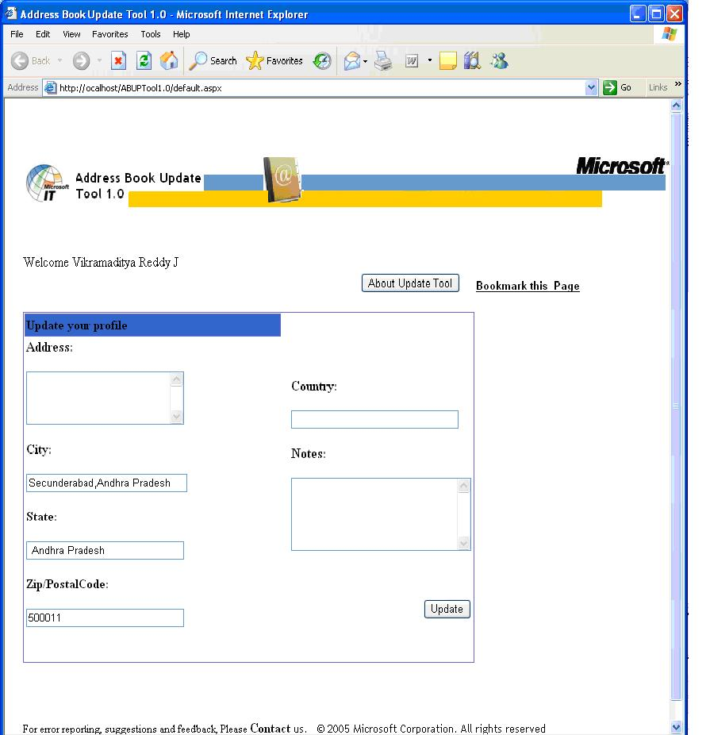
Figure 1: Snapshot of the address book update tool.

  - Workflow

Workflow Diagram

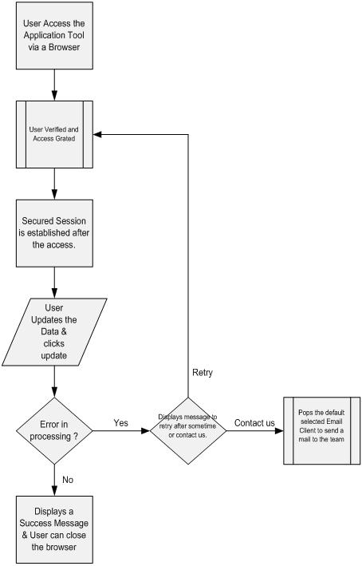

- Deployment Considerations
  - Deployment Diagram

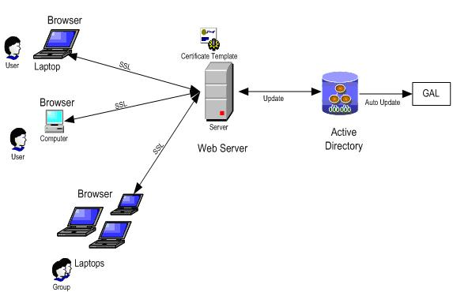

  - Business Tasks
  - Production Support Tasks
- Issues

# | Action Item / Issue | Status | Owner | Close date | Closed by

** Action items are bug reports.

